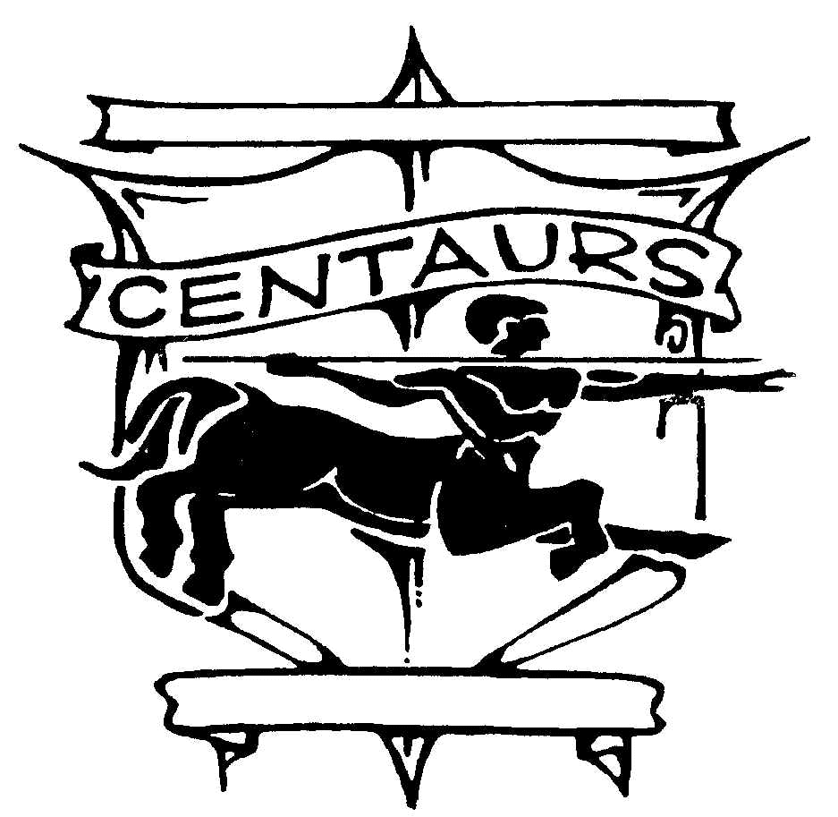
SCHOOL IMPROVEMENT (SI) COUNCIL
Tuesday, November 10, 2009 – 6:00 p.m. – 7:00 p.m.
CCHS – Library

Agenda

- GENERAL ITEMS
  - Welcome & Introductions Farris
  - Calendar Items
    - AVPA Showcase Assembly – 12/9
    - College Financial Aid Night – 12/9, 7-8:30pm
    - Booster Club Meeting – 12/14, 7-9pm
    - AVPA Winter Music Concert – 12/15, 7-9pm
    - Winter Break – 12/21 – 1/1
  - Student Representative Report Student Rep
  - PTSA Report Pam
  - Principal’s Report Pam
  - ELD Report Dylan

- PRESENTATIONS
  - ELAC Representative Nominations Dylan
    - Chairperson Nominations
  - CELDT – What does it mean for your student? Julie Groya
  - Notes from the Counselor Lisa Cooper

- ENTERTAINMENT
  - Holiday Carols Chamber Singers

- ACTION ITEMS
  - Approve minutes from previous meeting.

- Other Business

- Adjournment

Next Meeting, January 12, 2009, 6pm
CCHS – Faculty Lounge

